Hotel Reservation
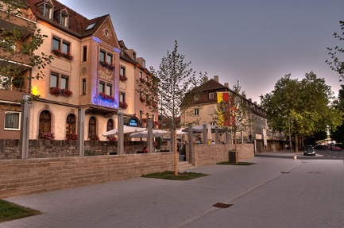
Venue:
Hotel Walfisch
Am Pleidenturm 5
97070 Wuerzburg
Germany
Room Rate: € 118 per night/room incl. VAT
Breakfast: € 12.50 per person/day

Name, First Name:

Organization:

Email:

Phone:

Arrival Date:

Departure Date:

Dietary Requirements:

Other comments:

Cancelation policy: You can cancel your room until 48h prior arrival.
Payment: You can pay your room directly in the hotel after your arrival.
Please notice: All partners cover their hotel costs individually (individual CARAMBA travel budgets).
Please send your reservation to Mrs. Schwarzmeier walfisch@hotel-walfisch.com.

